LED Torch Soldering Guide

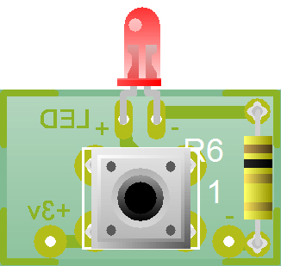

LED

1Ω Resistor

6x6 Switch

Notes

* The switch will only fit one way, with the legs of the switch facing towards the shorter sides of the PCB.
* The LED is 3mm in size, and must be soldered with the LED flush against the top side of the board.
* LEDs are polarised so must be soldered the right way around. The positive (*longer*) leg of the LEDs should be soldered to a “+” LED pad on the PCB.
* The 1 Ω Resistor used in this project can be obtained from your teacher
* Strip and solder around 5cm of solid core wire in the holes marked +3v and – (these will be used to connect to the batteries within the case)